Asia-China-Coin-Collections

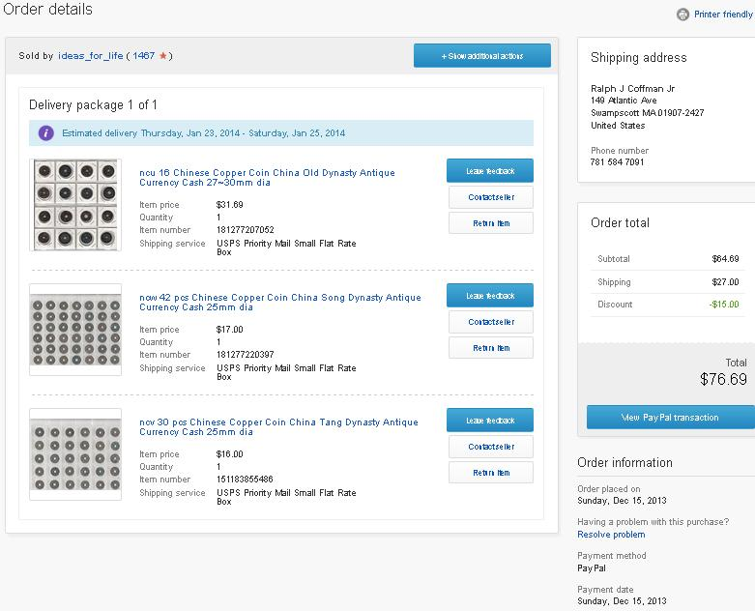

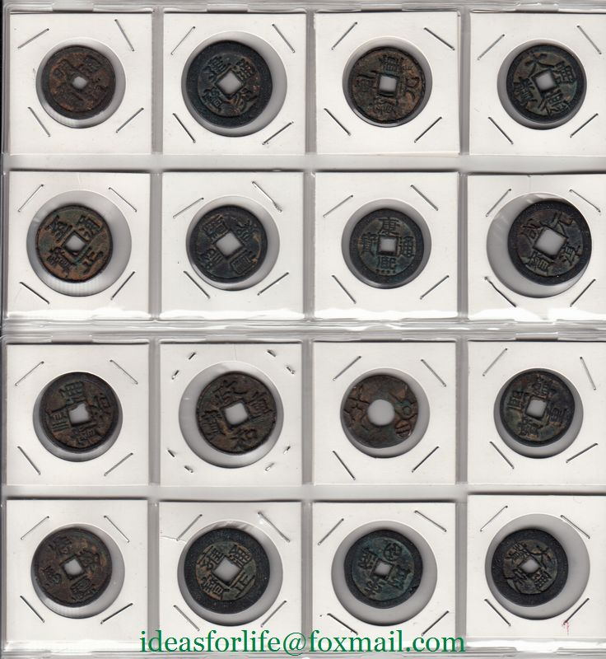 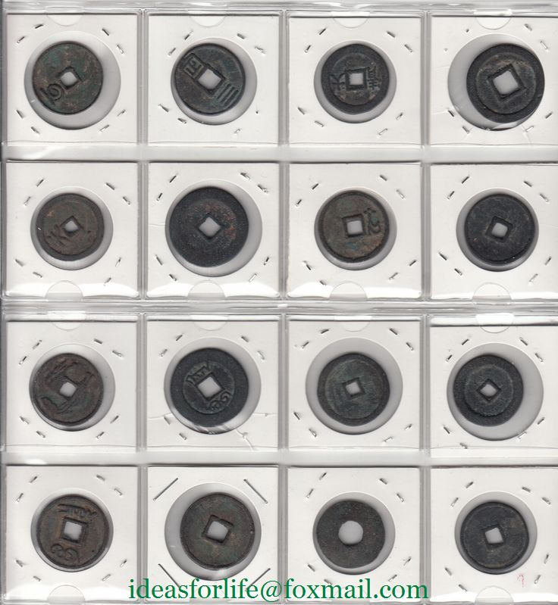

16 pieces of old copper coins About 2.5~3 cm dia.

155g in weight. About 210g after packing.

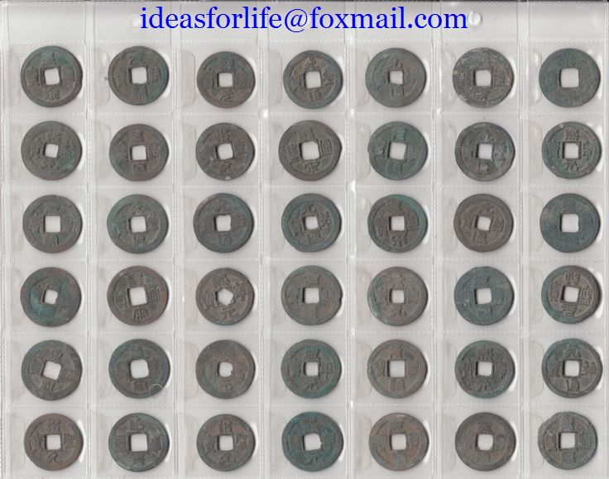 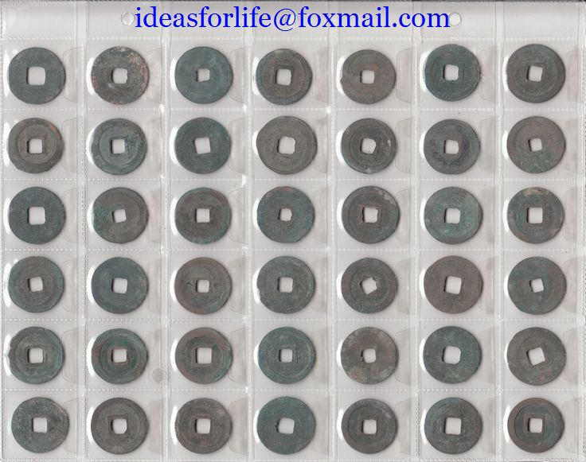

42 pieces of old copper coins About 2.5 cm dia.

195g in weight. About 240g after packing.

**Packed with a sheet of plastic film album.**

Chinese Song Dynasty. Same with the picture.

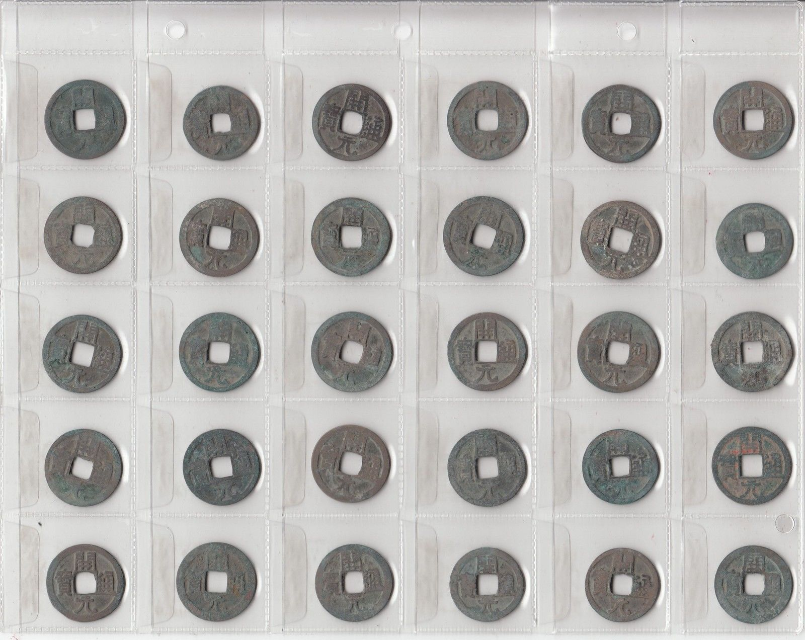

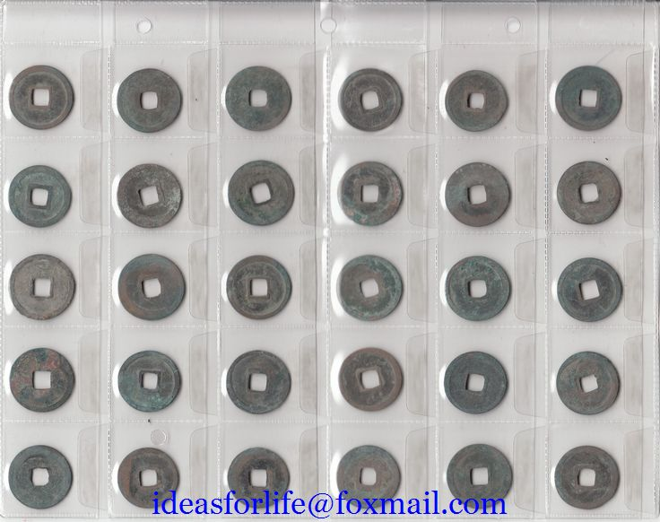

42 pieces of Kai Yuan Tong Bao copper coins.

About 2.5 cm dia.

135g in weight. About 190g after packing.

**Packed with a sheet of plastic film album.**

Chinese Tang Dynasty. Same with the picture.

About Kai Yuan Tong Bao开元通宝:

At the beginning of the Tang Dynasty, the *wu zhu* (五 铢) coins of the Sui Dynasty (581-618) were still in common use.  
  
However, in the 4th year (621) of the *Wu De* (武德) reign of Emperor Gaozu (高 祖) use of the *wu zhu*wasabolished.  A new coin began to be cast with the inscription *[kai yuan tong bao](http://primaltrek.com/charmfeatures.html" \l "kai_yuan)* (开元通宝) under the strict standard that ten of the new coins would be equal in weight to one *[liang](http://primaltrek.com/charmcoins.html" \l "liang)* (两).  
  
This marked a monumental change in the history of Chinese coinage.  Chinese coins would no longer be named after their weight, such as["half tael" (](http://primaltrek.com/charmcoins.html" \l "qin_ban_liang)*ban liang* [半两)](http://primaltrek.com/charmcoins.html" \l "qin_ban_liang) or ["five](http://primaltrek.com/charmcoins.html" \l "wu_zhu_coins) *zhu*" (*wu zhu* 五铢).  Instead, cash coins would have inscriptions with *[tong bao](http://primaltrek.com/guide.html" \l "origin_tong_bao_yuan_bao_zhong_bao)*(通寶), *yuan bao* (元 寶) and *zhong bao* (重 寶).  
  
Another important change was that the coin inscription would no longer be written in the ancient *zhuan shu* (篆书) or "seal" script.  The coin inscription would now be written in *li shu* (隶书) or "official" script which is a square and plain style of Chinese calligraphy.  
  
Emperor Gaozu had one of the Tang Dynasty's most famous calligraphers, Ouyang Xun (欧阳询), wrote the inscription for the new coin.  
  
These changes meant that the more that 700 year "reign" of the *wu zhu* (五铢) coin had finally come to an end.  The new *kai yuan tong bao*, with an inscription stipulating *tong bao* ("universal" or "circulating" currency) instead of its weight, and written in "official" script instead of "seal" script, would become the model for most of the coins cast in the dynasties that followed.  
  
The *kai yuan tong bao* would continue to be cast for 200 years.  So great was the influence of the new Tang Dynasty coin that it also became the model for the coinage of Japan, [Korea](http://primaltrek.com/koreancoins.html) and Annam (Vietnam).